Lab 2.8.2: Challenge Static Route Configuration

Topology Diagram
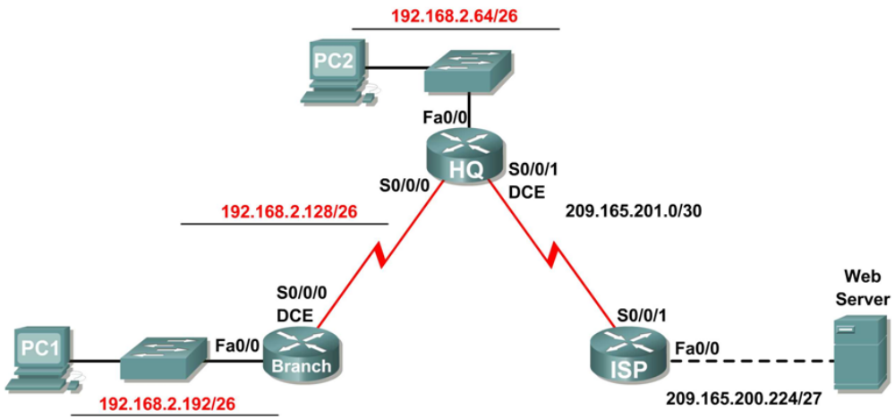

Addressing Table
Device | Interface | IP Address | Subnet Mask | Default Gateway
BRANCH | Fa0/0 | 192.168.2.193 | 255.255.255.192 | N/A
BRANCH | S0/0/0 | 192.168.2.129 | 255.255.255.192 | N/A
HQ | Fa0/0 | 192.168.2.65 | 255.255.255.192 | N/A
HQ | S0/0/0 | 192.168.2.130 | 255.255.255.192 | N/A
HQ | S0/0/1 | 209.165.201.2 | 255.255.255.252 | N/A
ISP | Fa0/0 | 209.165.200.225 | 255.255.255.224 | N/A
ISP | S/0/0/1 | 209.165.201.1 | 255.255.255.252 | N/A
PC1 | NIC | 192.168.2.253 | 255.255.255.192 | 192.168.2.193
PC2 | NIC | 192.168.2.94 | 255.255.255.192 | 192.168.2.65
Web Server | NIC | 209.165.200.253 | 255.255.255.224 | 209.165.200.225

Learning Objectives
Upon completion of this lab, you will be able to:
- Subnet an address space given requirements.
- Assign appropriate addresses to interfaces and document.
- Cable a network according to the Topology Diagram.
- Erase the startup configuration and reload a router to the default state.
- Perform basic configuration tasks on a router.
- Configure and activate Serial and Ethernet interfaces.
- Determine appropriate static, summary, and default routes.
- Test and verify configurations.
- Reflect upon and document the network implementation.

Scenario
In this lab activity, you will be given a network address that must be subnetted to complete the addressing of the network shown in the Topology Diagram. The addressing for the LAN connected to the ISP router and the link between the HQ and ISP routers has already been completed. Static routes will also need to be configured so that hosts on networks that are not directly connected will be able to communicate with each other.
Task 1: Subnet the Address Space.
Step 1: Examine the network requirements.
The addressing for the LAN connected to the ISP router and the link between the HQ and ISP routers has already been completed. You have been given the 192.168.2.0/24 address space to complete the network design. Subnet this network to provide enough IP addresses to support 60 hosts.
Step 2: Consider the following questions when creating your network design:
How many subnets need to be created from the 192.168.2.0/24 network? __________ 3
What are the network addresses of the subnets?
Subnet 0: ________________________________________ 192.168.2.0/26
Subnet 1: ________________________________________ 192.168.2.64/26
Subnet 2: ________________________________________ 192.168.2.128/26
Subnet 3: ________________________________________ 192.168.2.192/26
What is the subnet mask for these networks in dotted decimal format? __________________________ 255.255.255.192
What is the subnet mask for the network in slash format? __________ 26
How many usable hosts are there per subnet? __________ 62
Step 3: Assign subnetwork addresses to the Topology Diagram.
- Assign subnet 1 to the LAN attached to HQ.
- Assign subnet 2 to the WAN link between HQ and BRANCH.
- Assign subnet 3 to the LAN attached to BRANCH.
- Subnet 0 will be available for future expansion.
Task 2: Determine Interface Addresses.
Step 1: Assign appropriate addresses to the device interfaces.
- Assign the first valid host address in subnet 1 to the LAN interface on HQ.
- Assign the last valid host address in subnet 1 to PC2.
- Assign the first valid host address in subnet 2 to the WAN interface on BRANCH.
- Assign the second valid host address in subnet 2 to the WAN interface on HQ.
- Assign the first valid host address in subnet 3 to the LAN interface of BRANCH.
- Assign the last valid host address in subnet 3 to PC1.
Step 2: Document the addresses to be used in the table provided under the Topology Diagram.
Task 3: Prepare the Network.
Step 1: Cable a network that is similar to the one in the Topology Diagram.
You can use any current router in your lab as long as it has the required interfaces as shown in the topology.
Step 2: Clear any existing configurations on the routers.
Task 4: Perform Basic Router Configurations.
Perform basic configuration of the BRANCH, HQ, and ISP routers according to the following guidelines:
- Configure the router hostname.
- Disable DNS lookup.
- Configure an EXEC mode password.
- Configure a message-of-the-day banner.
- Configure a password for console connections.
- Configure a password for VTY connections.
- Synchronize unsolicited messages and debug output with solicited output and prompts for the console and virtual terminal lines.
- Configure an EXEC timeout of 15 minutes.
Task 5: Configure and Activate Serial and Ethernet Addresses.
Step 1: Configure the interfaces on the BRANCH, HQ, and ISP routers.
Configure the interfaces on the BRANCH, HQ, and ISP routers with the IP addresses from the table provided under the Topology Diagram. When you have finished, be sure to save the running configuration to the NVRAM of the router.
Step 2: Configure the Ethernet interfaces.
Configure the Ethernet interfaces on PC1, PC2, and the Web Server with the IP addresses from the table provided under the Topology Diagram.
Task 6: Verify Connectivity to Next-Hop Device.
You should not have connectivity between end devices yet. However, you can test connectivity between two routers and between and end device and its default gateway.
Step 1: Verify BRANCH and HQ connectivity.
Verify that BRANCH can ping across the WAN link to HQ and that HQ can ping across the WAN link that it shares with ISP.
Step 2: Verify PC1, PC2, and Web Server connectivity.
Verify that PC1, PC2, and the Web Server can ping their respective default gateways.
Task 7: Configure Static Routing on BRANCH.
Step 1: Consider the type of static routing that is needed on BRANCH.
What networks are present in the BRANCH routing table? List the networks with slash notation.
________________________________________ 192.168.2.128/26
________________________________________ 192.168.2.192/26

What networks are missing from the BRANCH routing table? List the networks with slash notation.
________________________________________ 192.168.2.64/26
________________________________________ 209.165.201.0/30
________________________________________ 209.165.200.224/27

Can one summary route that includes all of the missing networks be created? __________ no
How many WAN routes are available to traffic leaving the LAN connected to BRANCH? __________ 1
Step 2 Configure BRANCH with a default static route pointing to HQ.
Because BRANCH is a stub router, we should configure BRANCH with a default static route pointing to HQ. Record the command to configure a default static route using the appropriate exit interface.
________________________________________________________________________________ BRANCH(config)#ip route 0.0.0.0 0.0.0.0 serial0/0/0
Step 3 View the routing table of BRANCH to verify the new static route entry.
You should see a Gateway of Last Resort set on BRANCH.
Without testing it first, do you think that PC1 can now successfully ping PC2? __________ no
Why or why not?
___________________________________________________________________________________
___________________________________________________________________________________
___________________________________________________________________________________
PC1 cannot successfully ping PC2. Although PC2 will receive the ping packet from PC1 and send a ping reply back to HQ, HQ does not yet know how to route packets back to PC1’s subnet.
Task 8: Configure Static Routing on HQ.
Step 1: Consider the type of static routing that is needed on HQ.
What networks are present in the HQ routing table? List the networks with slash notation.
________________________________________ 192.168.2.128/26
________________________________________ 192.168.2.64/26
________________________________________ 209.165.201.0/30

What networks are missing from the HQ routing table? List the networks with slash notation.
________________________________________ 192.168.2.192/26
________________________________________ 209.165.200.224/27

Can one summary route that includes all of the missing networks be created? __________ no
HQ is in a unique position as the hub router in this hub-and-spoke topology. Traffic from the BRANCH LAN destined for the Internet must pass through HQ. HQ must be able to send any traffic for which it does not have a route to ISP. What kind of route would you need to configure on HQ to solve this problem?
___________________________________________________________________________________ a default static route pointing to ISP
HQ is also the intermediary for any traffic from the Internet destined for the BRANCH LAN. Therefore, HQ must be able to route to that LAN. What kind of route would you need to configure on HQ to solve this problem?
___________________________________________________________________________________ a static route pointing to the BRANCH LAN
Step 2: Configure HQ with a static route.
Configure HQ with a static route to the BRANCH LAN using the Serial 0/0/0 interface of HQ as the exit interface. Record the command that you used.
___________________________________________________________________________________ HQ(config)#ip route 192.168.2.192 255.255.255.192 serial 0/0/0
Step 3: Configure HQ with a default static route.
Configure the HQ router with a default static route pointing to ISP using the next-hop IP address. Record the command you used.
___________________________________________________________________________________ HQ(config)#ip route 0.0.0.0 0.0.0.0 209.165.201.1
Step 4: View the routing table of HQ to verify the new static route entries.
Without testing it first, do you think that PC1 can now successfully ping PC2? __________ yes
Why or why not?
___________________________________________________________________________________
___________________________________________________________________________________ PC1 can now successfully ping PC2. HQ now has a route back to the BRANCH LAN.
Without testing it first, do you think that PC1 or PC2 can now successfully ping the Web Server? __________ no
Why or why not?
___________________________________________________________________________________
___________________________________________________________________________________
___________________________________________________________________________________
___________________________________________________________________________________ PC1 and PC2 cannot successfully ping the Web Server. Although the Web Server will receive the ping packets from PC1 and PC2 (HQ is sending default traffic to ISP), ISP does not yet know how to route packets back to HQ or BRANCH networks.
Task 9: Configure Static Routing on ISP.
In a real-world implementation of this topology, you would not be configuring the ISP router. However, your service provider is an active partner in solving your connectivity needs. Service provider administrators are human, too, and make mistakes. Therefore, it is important that you understand the types of errors an ISP could make that would cause your networks to lose connectivity.
Step 1: Consider the type of static routing that is needed on ISP.
What networks are present in the ISP routing table? List the networks with slash notation.
________________________________________ 209.165.201.0/30
________________________________________ 209.165.200.224/27

What networks are missing from the ISP routing table? List the networks with slash notation.
________________________________________ 192.168.2.64/26
________________________________________ 192.168.2.128/26
________________________________________ 192.168.2.192/26

Can one summary route that includes all of the missing networks be created? __________ yes
Step 2: Configure ISP with a summary static route.
Using the next-hop IP address, configure ISP with a summary static route that includes all of the subnets that are missing from the routing table. Record the command that you used.
________________________________________________________________________________ ISP(config)#ip route 192.168.2.0 255.255.255.0 209.165.201.2
Note: The summary route will also include the subnet zero route that is reserved for future expansion.
Step 3: View the routing table of ISP to verify the new static route entry.
Task 10: Verify the Configurations.
Answer the following questions to verify that the network is operating as expected:
From PC2, is it possible to ping PC1? __________ yes
From PC2, is it possible to ping the Web Server? __________ yes
From PC1, is it possible to ping the Web Server? __________ yes
The answer to these questions should be yes. If any of the above pings failed, check your physical connections and configurations. For a review of basic troubleshooting techniques, see Lab 1.5.1, “Cabling a Network and Basic Router Configuration.”
What routes are present in the routing table of BRANCH?
________________________________________ 192.168.2.128/26
________________________________________ 192.168.2.192/26
________________________________________ 0.0.0.0/0

What routes are present in the routing table of HQ?
________________________________________ 192.168.2.64/26
________________________________________ 192.168.2.128/26
________________________________________ 192.168.2.192/26
________________________________________ 209.165.201.0/30
________________________________________ 0.0.0.0/0

What routes are present in the routing table of ISP?
________________________________________ 192.168.2.0/24
________________________________________ 209.165.200.224/27
________________________________________ 209.165.201.0/30
Task 11: Reflection
If a default static route was not configured on BRANCH, how many individual static routes would be needed for hosts on the BRANCH LAN to communicate with all of the networks in the Topology Diagram? __________ 3
If a summary static route was not configured on ISP, how many individual static routes would be needed for hosts on the ISP LAN to communicate with all of the networks in the Topology Diagram? __________ 3
Task 12: Document the Router Configurations
On each router, capture the following command output to a text (.txt) file and save for future reference.
- Running configuration
- Routing table
- Interface summarization
Task 13: Clean Up
Erase the configurations and reload the routers. Disconnect and store the cabling. For PC hosts that are normally connected to other networks (such as the school LAN or to the Internet), reconnect the appropriate cabling and restore the TCP/IP settings.

